Tribhuvan University
Institute of Science and Technology
2066
✡
Bachelor Level/ First Year/ Second Semester/ Science Full Marks: 60
Computer Science and Information Technology (CSC 152) Pass Marks: 24
(Discrete Structure) Time: 3hours
Candidates are required to give their answers in their own words as for as practicable. The figures in the margin indicate full marks.
Attempt all questions:
Group A (10x2=20)
- Define proposition and its negation with an example.
- Show that $¬$(p V q) and $¬$pᴧ $¬$q are logically equivalent.
- State which rule of inference is the basis of the following argument; “It is below freezing now. Therefore, it is either below freezing or raining now.”
- State the Pigeonhole principle. How many students must be in class to guarantee that at least two students receive the same score on the final exam is graded on a scale from 0 to 100?
- Let {an} be a sequence that satisfies the recursion relation an = an-1 - an-2 for n≥2 and suppose that a0 = 3 and a1=5. Find the values a2 and a3.
- Let G be the grammar with vocabulary V = {S, A, a, b}, t = {a, b}, starting symbol S and production P = {S→ aA, S→ b, A→ aa}. What is L(G), the language of this grammar ?
- Determine the kleen closures of the sets A = {0}, B = {0, 1}, C = {11}.
- How many edges are there in graph with 10 vertices each of degree six?
- Which of the undirected graphs in the following have an Euler path?
Determine the chromatic number Kn.

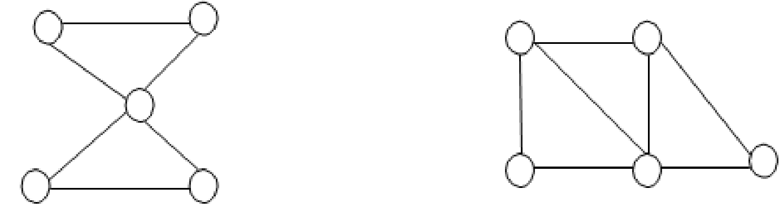
a b a b
e
c d c d e
Group B (5x4=20)

- Differentiate between existential and universal quantifiers with suitable examples.
- Find the solution of the recursion relation an = an-1 + 2an-2 with a0 = 2 and a1=7? OR
Find an explicit formula for the Fibonacci numbers.
- Define deterministic finite state automata. Construct a DFA whose language is the set of strings that ends with 111 and contains odd number of 1’s.
- Prove that an undirected graph is a tree if and only if there is a unique simple path between any two of its vertices.

- Prove that an undirected graph is a tree if and only if there is a unique simple path between any two of its vertices.

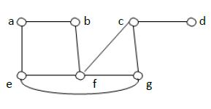
- Find a spanning tree of the simple graph in the following graph, if it exists.

Can there be more possibilities?
Group C (5x8=40)

16. Discuss the techniques of proofs by contradiction and by cases with suitable examples.
17. Describe linear homogeneous and linear non-homogeneous recurrence relations with suitable examples.
18. Explain non-homogeneous finite automata and language of NFA with suitable example.
19. State and prove the Max-flow and Min-cut theorem.

OR
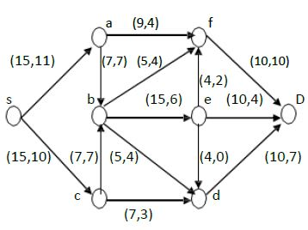
Find a maximum flow for the network in the figure below.

20. Define Hamiltonian paths and circuits with suitable examples for the existence and nonexistence. Show that has a Hamilton circuit whenever.

OR
Write the shortest path algorithm of Dijkstra for finding the shortest path between two vertices. What is the length of shortest path between a and z in the weighted graph in the following figure?

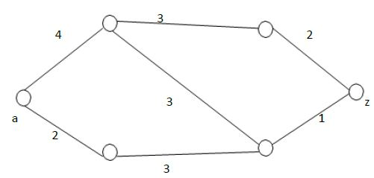

Apply the stated algorithm for finding the solution.

